**TREND ANALYSIS:**

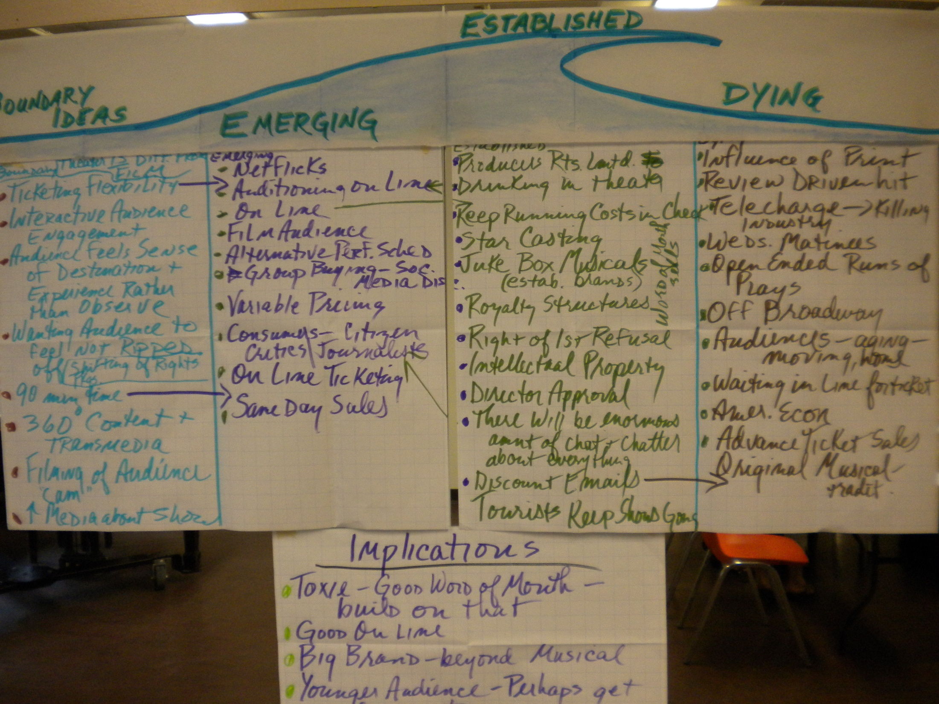***In Professional Meetings & Conferences, what are the trends/practices that are being adjusted in response to changing demands?***

|  |  |  |  |
| --- | --- | --- | --- |
| **Boundary**  Radical, bleeding edge, not accepted | **Emerging**  Experimental, gaining momentum | **Established**  Status quo, standard op. procedures, mainstream | **Dying**  No longer relevant, outdated, "out" |
| * Sending my avatar to the conference | * Facebook & linked connections before face to face * Virtual with video participation * World Cafe instead of poster sessions * Engage Gen Y discussions * Really healthy food * Green - no paper * Ted Talks, Ted X * Organize around a community demonstration * Look for innovation in community change work * Experiential - i.e., community field trip | * Using a logistics coordinator * Tracks for trainers & facilitators * Opportunity to exchange ideas; open space * Not rely on experts * Lots of interaction * Resources available to purchase * Meeting organizers as a profession * Pre-registering and paying up front * Book charting * Panel presentations * Calls for papers, abstracts * Business meeting held at front end or back end of annual conference * Importance of face to face gatherings and networking | * Keynote speakers are used less (at IAF) * Talking heads with Powerpoints * Large, face to face conference for 3-4 days in another location |
| **Board Reflection** | | | |
| * Learning components seems stagnant; have as many topics as possible vs. creating several prepared sessions; separating learning from seeing learning in practice, in action. * Combining the virtual with the face to face. If the virtual way is more cost effective, how do we include the face to face? * Exchange of best practices | | | |